**Checkpoint 1: Data**

**Star Stalker**

David Blalock, Keleigh Maddox, & Christine Woods

With joy in our eyes we began searching for our data. Unfortunately, we came to the realization that nobody likes to include geo data in Twitter and Instagram’s API is ridiculously simple and hard all at once.

So the scope of our project is morphing into our alternative idea. This idea is to search for celebrities in your specified area.

1. Our application will find the user’s current location as coordinates (latitude and longitude) using Google Maps API getCurrentLocation() function.

2. These coordinates will be implemented in the Twitter API search function which will return tweets in a certain radius specified by us.

3. There will be multiple api search calls with queries consisting of keywords that are indicative of a celebrity sighting such as: “just saw”, “just met”, “sighted”, etc. After getting the data, the app will parse through the tweets to find “celebrities” that have been mentioned. A “celebrity” at its simplest will be defined as a person with more than 3000 followers. The “celebrities” will be shown on the side panel, as “Nearest Stars”. Any of the tweets that have geo locations will be mapped.

Successful Data -> Query “ just met” + location of College Station

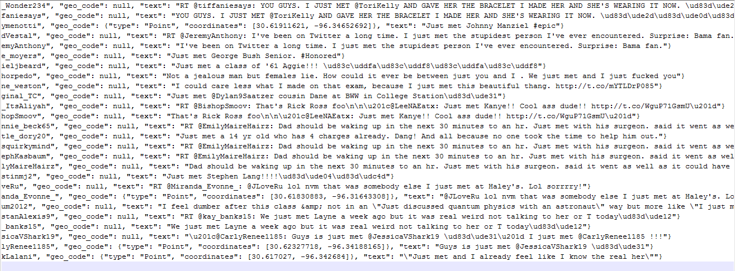

Examples of why our first idea failed:

Query - Kevin Sumlin

#Geo/#Total - 4/50 including: California, North Carolina, Ohio, and Port Arthur,Texas

Query -” just met” Ellen Degeneres

#Geo/#Total - 0/5 - not helpful

Query - just saw Ellen Degeneres

#Geo/#Total - 0/3 - not helpful

Query - Lady Gaga “just met”

#Geo/#Total - 1/17 included NY